**ITCS 6112 - Software System Design and Implementation**

**USER DOCUMENTATION**

**PROJECT GROUP MEMBERS:**

* Aravindharaj Rajendran
* Ankit Gujrati
* Dimple Sharma
* Veda Samhitha Vadlamudi
* Vishwanarayan Sriganesh

**SCREENSHOTS FOR THE APPLICATION’S GUI:**

1. ***Equipment Checkin and Checkout:***

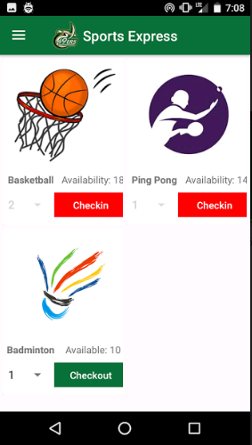

***2. User and Menu Options:***

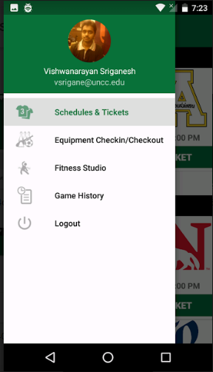

***3. Schedules and Tickets:***

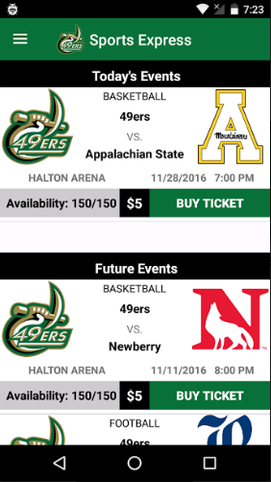

***4. Application/User Login:***

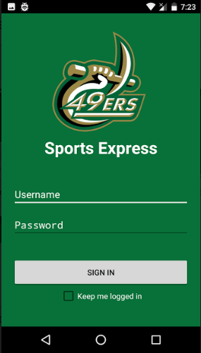

***5. Fitness Schedule:***

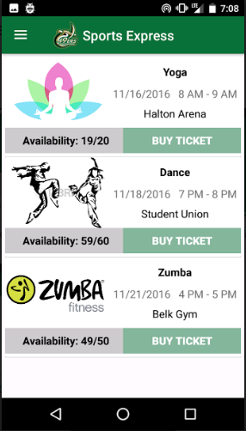

***6. Ticket History:***

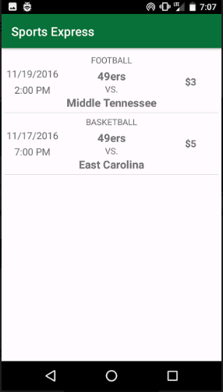

***8. User Profile:***

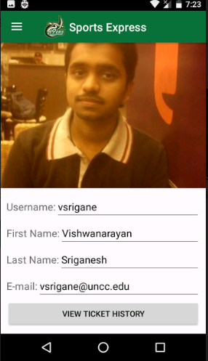

***9. Game History:***

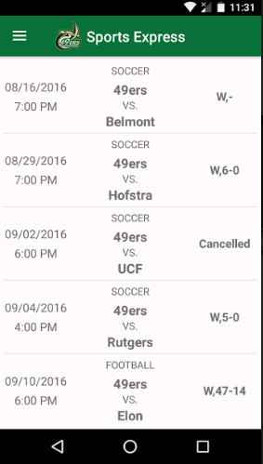

**NODE.JS CODE**